Permaculture Design Report

Property Description and Overview
Size: 5 Acres
Climate Zone: 5A
Climate Averages:
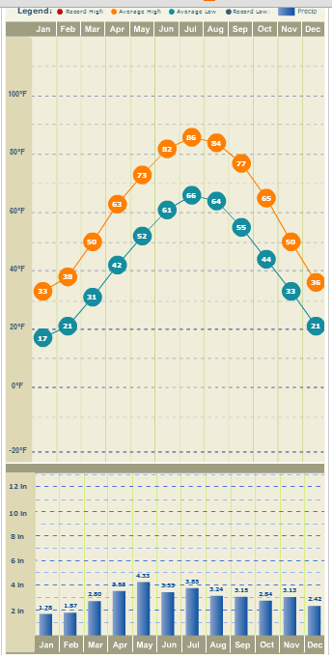

Plant Hardiness Zone: 5
Prevailing Wind Direction: SW
Soil Type: Clay

Landscape Description:
House is on the high point on the land. Water runs off other properties when it rains creating a moat around the house. One goal is to reduce water pooling around the home so we are going to try to harvest and hold the water before it gets to the home using ponds and swales.

Water
Standing water on the property after it rains.
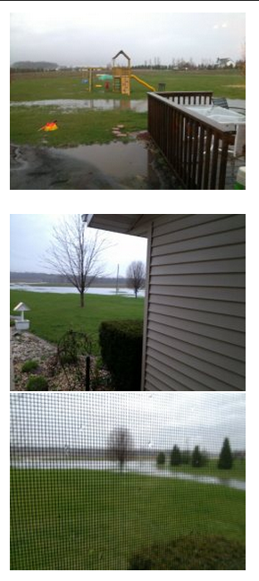

Soils
Very alkaline and in need of amendment. We are working to amend the soil as we add garden beds and swales.

Plans and Recommendations
Zone 0
House is already built and is not energy efficient at this time. Recommendation would be to install rain barrels on each corner of the home and use the rain water to water plants in Zone 1.

Zone 1
In this zone, a kitchen garden will be installed at the rear of the home right off the back deck with the following annuals: lettuces, herbs, chard, kale, cabbage, brussel sprouts and other leafy vegetables that do well in partial shade. Some tomatoes will also be planted here to the north of the house where they will receive full sun for most of the day.

Mini swales will be put in so as not to interfere with any buried lines or pipes. Here we will put fruit bushes and shrubs in. We will also put a 17x13 greenhouse with a chicken house attached to the west. A sliding door will be installed on either side of the coop so that chickens can be let in to forage in the greenhouse or out to forage in the gardens.

Vermaculture system for kitchen scraps will be to the north of the deck with a compost system to the west of the greenhouse outside the chicken coop.

Strawberries and roses will be planted on the south side of the house in a bed right outside the front door.

Zone 2
To the north of the house in this zone, perennial and annual woody beds will be installed as well as the main compost bin. This area gets full sun all day. There will also be one or two bee hives installed.

Annuals: Squashes, pumpkins, amaranth, peas, beans, cucumbers, carrots, peppers, garlic, onions, shallots and other vegetables needing full sun.

Perennials: Rhubarb, Jerusalem arthichoke, yacon, grapes, hops, kiwi, and asparagus.

To the south of the house there will be a couple of mini swales with fruit shrubs so as not to interfere with the line that goes from the generator to the well.

Zone 3
This zone is where the large swales will be built. Fruit and nut trees and fruit shrubs will be planted here.

There are already a few Bradford pear trees on the property, which I am told are fast growing but quick to die as well. We planted an apple and two mulberry trees last year. In the swales, we have plans to plant a variety of fruiting trees and shrubs including:

Nut trees
Apple trees
Pear trees
Cherry trees
Raspberries
Blueberries
Blackberries
Mulberries
Peach trees
Plum trees
Autumn Olive
Aronia
Nanking Cherry

To the east of the house, there are plans to build an outbuilding and perhaps a goat pen. A small portion of the land to the east will be left open for kids to play. The swales built to the northeast and south will provide privacy and a beautiful oasis for the kids to play in while we sit on the deck drinking coffee and smiling while they play.

To the far north of the property, two ponds will be built in zone 3. A dam and a spillway will be put in on the northeast pond and will be used when the rain water overflows the pond. The water will continue to flow south to fill the swales. Both ponds will be stocked.

Zone 4
There is a good amount of pasture on the property. Zone 4 will be allowed to continue being a pasture. We will also plant bamboo to use for building small fences and screens.

Zone 5
This zone will be small due to the number of swales and ponds and the amount of building we will be doing. It will be to the west of the propane tank.

Drawing of Design Proposal